

CST3515-Embedded Linux System and Application Development

INDIVIDUAL PROJECT REPORT

**NAME**- REHMAT.P.NALBAN

**MISIS NO.** - M00650043

**TITLE**- SMART HOME AUTOMATION

**DATE** - 30/04/2020

LIST OF CONTENTS

|  |  |
| --- | --- |
| TITLE | PAGE NO. |
| 1. ABSTRACT 2. INTRODUCTION 3. RASPBERRY PI SETUP 4. PIR SENSOR 5. DHT11 SENSOR 6. IMPLEMENTATION 7. CONCLUSION 8. REFERENCES | 3    3  5  11  14  17  22  23 |

ABSTRACT

In this report, A small review of Raspberry pi is given and provides detail on how smart home automation is built with IoT devices. A brief explanation of the sensors which is used in the system is also given. This system would protect the smart home from illegal activities such as theft, danger, etc. Using this design, the sensors and appliances are operated and controlled by the Raspberry Pi. For example, if a person enters the room, the motion sensor detects its presence and lights up the room. And also provides a feature of monitoring and maintaining room temperature with the help of a temperature sensor. if the room temperature is high, the DC fan would be turned on.

Keywords- Raspberry pi, DHT sensor, PIR sensor, LED, Relay, DC fan.

INTRODUCTION

Raspberry pi is a powerful and important development in the IoT. There are many important functions provided in the Raspberry pi which are different and more powerful. It is more powerful in the term of computation and processing. Raspberry pi has an advantage in addition to that it has better memory capacity and it could also integrate different types of sensors and actuators which is more preferred when compared to a similar featured Arduino. Different type of sensors could integrate with Raspberry pi many features could be processed, the processing capability is good. Using Raspberry pi would be preferred when the sensor data require more processing eg, imaging sensors, multimedia sensors, etc. A raspberry pi enabled IoT node could be said as more powerful than the Arduino based node. As far as costing is concerned, Raspberry pi is a little more in cost hence depending on the requirement of a particular IoT application and development to be made. A decision of using a raspberry pi or Arduino can be made. We can configure raspberry pi as a web server or an edge device hence, there are different capabilities for more computation and processing. More computation also means there is more power consumption it is important to understand the application and priority of computation, costing, power consumption, etc when we choose Arduino or Raspberry pi. Raspberry pi is a micro-sized computer specifically a single board computer which is a very low-cost device and easy to access. This makes it more popular with respect to IoT and small electronic projects. Raspberry pi could still be said as cost-effective when we compare it with laptops and computers but, it would have a memory limitation of 512 MB or 256 MB. A variety of programs would work on the raspberry pi so new things could be tried on it which one cannot do with the PC.

The operating system that sits on Raspberry pi is the Raspbian OS. This is a Linux based operating system specially designed for the raspberry pi. Raspbian is an officially supported operating system by the Raspberry pi foundation. It could be directly downloaded from its official website using NOOBS (New Out Of Box Software) for PC and Mac Debian with raspberry pi desktop is the foundation operating system. There are many other operating systems for the Raspberry pi like Ubuntu MATE, SANNPY Ubuntu core, Windows 10 IoT core, and other Linux based operating system. (Monk, 2013)

One can also install a Raspberry pi operating system without NOOBS. This is directly installing the Raspbian image. One has to download the zip file Raspbian ‘stretch with Desktop’ from the official raspberry pi website. Win32 Manager is a tool that will copy the image on the SD card very easily.

The software would provide a platform for projects that are coded in python, C, C++, JAVA BASIC, Perl, and Ruby.

The technical features of the Raspberry pi are:

1. Dimension; 85.6 mm x 56 mm
2. Camera serial interface(CSI) , Display serial interface(DSI)
3. 40 pins GPIO header.
4. The power supply of 2A
5. 4 USB 2.0 ports
6. Audio-video jack, HDMI
7. Slot for MicroSD card
8. 512 MB RAM
9. 10/100 Mbps Ethernet ports

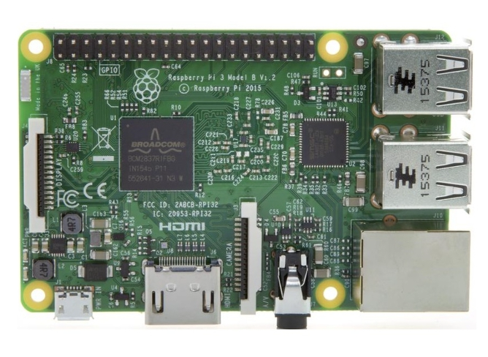

Raspberry PI SETUP

Raspberry pi was designed and built in such a way that it made it easier for students to learn programming in various languages like python, JAVA, etc. The setup of the Raspberry pi is done in the following steps which are:

1. Download Raspbian ISO file from the official Raspberry pi website and save it on the Desktop.

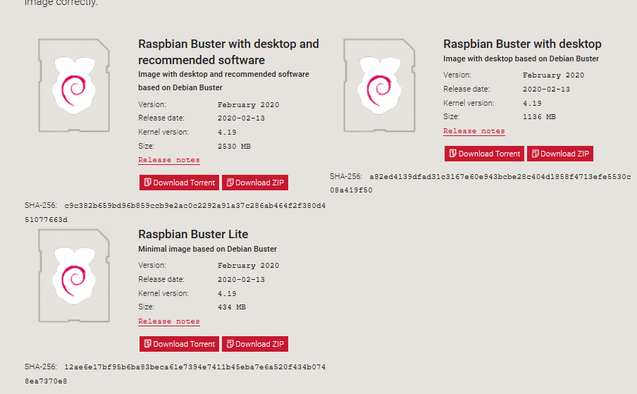

1. MicroSD card is required for the setup. Before using it, the SD card has to be formatted. The formatting can be done by installing SD Card Formatter.

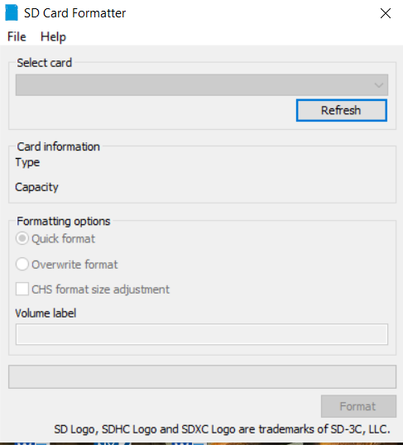

1. Download Win32Manager from their official website. After the Image file is downloaded, We write it on SD card with help of Win32Manager.

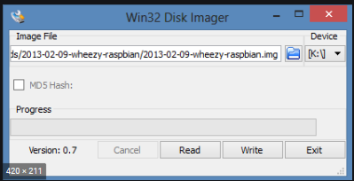

1. Include ssh file into the written MicroSD card.

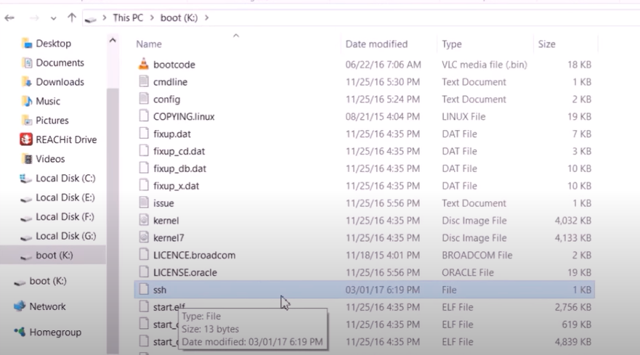

1. Download putty, VNC server and VNC viewer on the PC. After the installation of these programs is done, insert the MicroSD card into the Raspberry pi SD card slot.

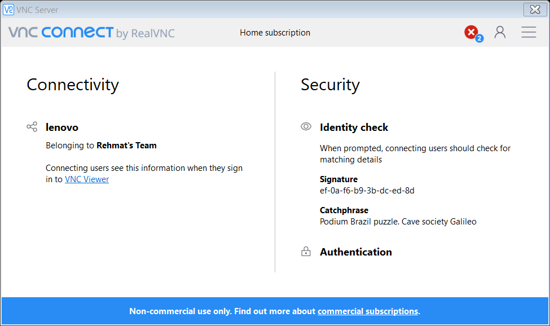

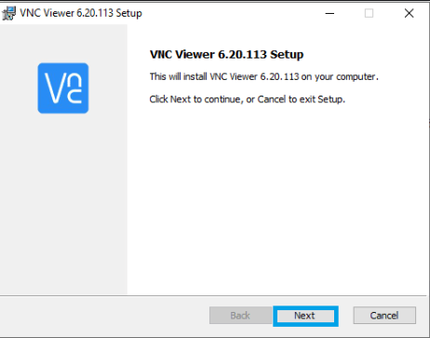

1. Connect the Raspberry pi to the PC using Ethernet (RJ45) cable with the USB power cable.
2. Enter the IP address of the Raspberry PI or ‘raspberrypi.local’ on the putty program. The terminal would show up and ask for username and password.

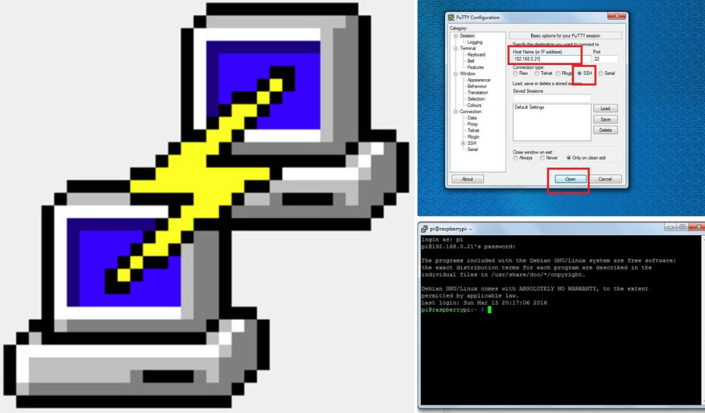

1. The default username- pi and default password- raspberry
2. After entering the usernames and passwords, it would get connected to the Raspberry pi.

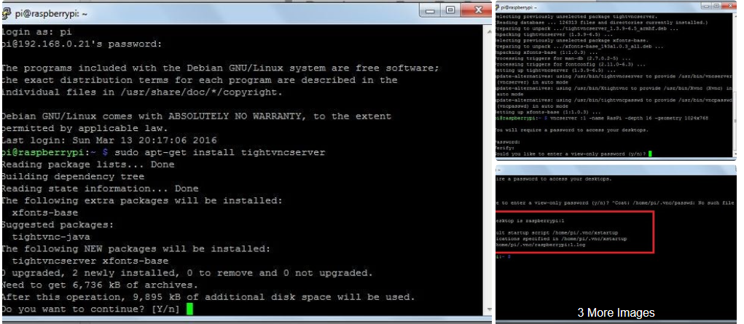

1. The configuration is required to display the Raspbian Operating system using VNC. We configure by running the command sudo raspi-config. A list of options is displayed and select Interfacing Options, then VNC, and enable it.

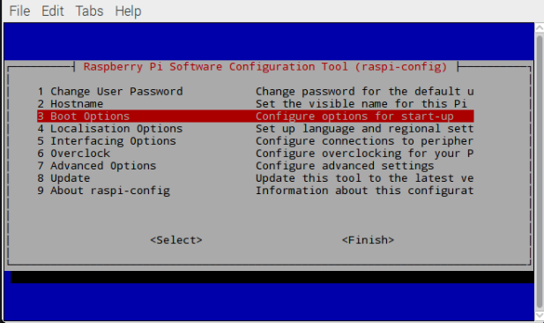

1. Raspberry pi uses VNC server and is configured as login mode to be used with user accounts on the machine. The connection method used here does not provide support for VNC clients. So VNC viewer is required.

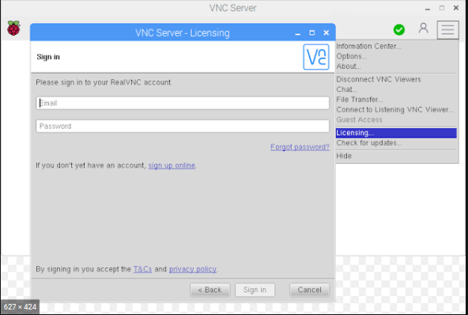

1. The installed VNC viewer would show up the IP address provided by the server and we just have to enter the username as pi and the new password.

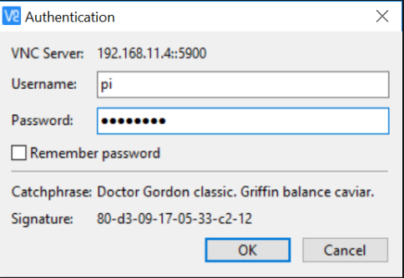

1. It would display the Raspbian Operating System Desktop. This means that the Raspberry pi is connected and can be controlled with the VNC viewer interface from PC

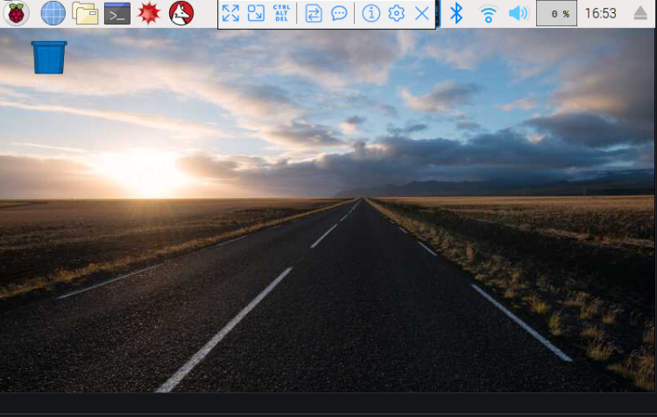

PIR SENSORS (PASSIVE INFRARED SENSORS)

For the home automation system project that uses Raspberry pi will be gaining popularity hence it should be cost-effective as well as should be efficient. The backbone of the project are sensors which detect conditions and react as action on equipment. PIR motion sensors would satisfy both above conditions. The PIR sensor is basically made up of Pyroelectric sensors these detect the level of infrared radiation. Using the fact that everything emits some low-level radiation the sensor in the motion detector would detect this as the infrared levels would change the levels in the circuitry of Pyroelectric sensors would emit a digital output pulse from the analog sensor. (PIR Motion Sensor, 2020)

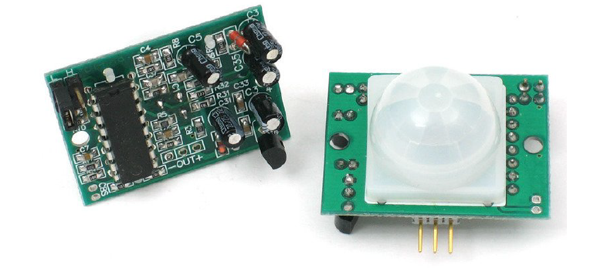

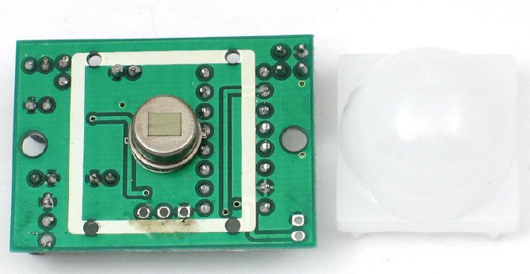

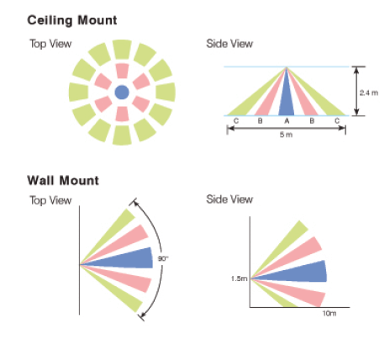

These are sensors that are sensitive to infrared rays and they are used for motion detection. The PIR relates to the analog output waveform and it will subject this to action. PIR is gaining its popularity in the industry of embedded systems and IoT (Internet of Things). They are low-cost motion sensors that respond to infrared emitting subjects (humans or animals) that pass through a certain range called the field of view (FoV). In the home automation system, this sensor is used for switching on the room lights. Apart from this PIR sensors are widely used in biomedical applications etc. The FoV of the sensor is the area where it detects the analog signals modulates it and determines its presence. These sensors could also be used to determine the range of the subject using a certain mathematical model.

The FoV of the sensor is extended by using Fresnel lens. The larger aperture and short focal length is provided by these lens without changing the material’s size and mass. The focus of lens is placed by the sensing element. By using different types of lens, the conical FoV can be accomplished with sizes like shorter, longer, broader, narrower, etc. the FoV of the sensor provides eleven sectors which spans from -50 and +50 and detects motion from 4-10 metres. The Fresnel lens is show below

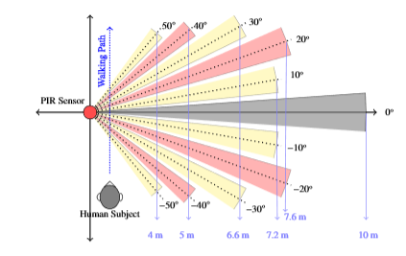

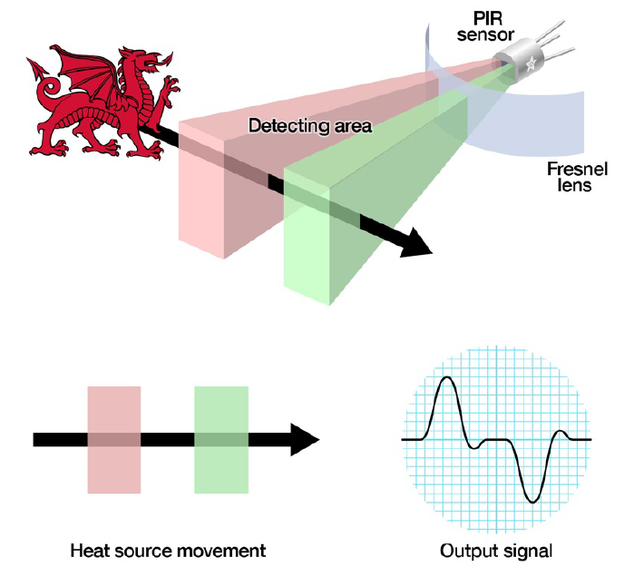

**SPECIFICATION OF THE PIR SENSOR**

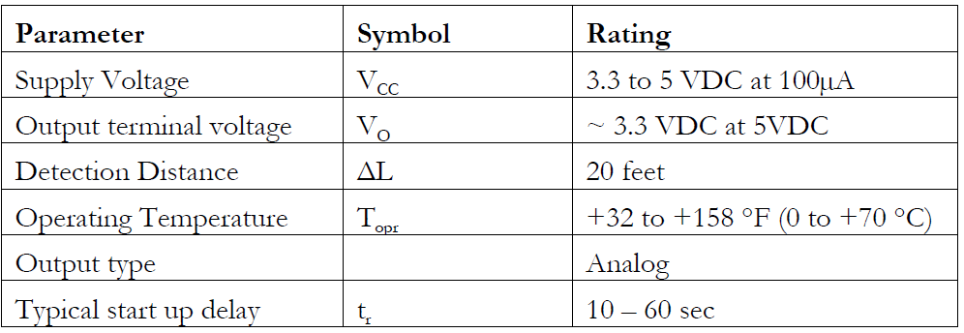

The advantages of the PIR sensor are

* The product is reasonably priced.
* Unlike the radar system, it is a passive detecting system
* The power consumption is relatively low
* Accurate detection even in narrow areas and very precise optics
* It is compatible to work with a variety of microcontrollers.
* Suitable also due to its small size.

DHT SENSORS

For measuring the humidity and temperature, a sensor is used which is efficient and economical. It can measure humidity between 20 and 90% and temperature between the range 0 to 50 degrees Celsius. It is the DHT11 sensor which returns an 8-bit resolution value on detecting the analog humidity and temperature. (DHT11 Sensor Pinout, Features, Equivalents & Datasheet, 2020)

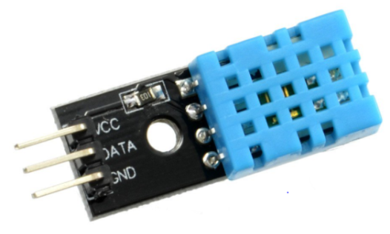

**ELEMENTS OF THE DHT SENSOR**

These sensors consist of two elements which are the following:

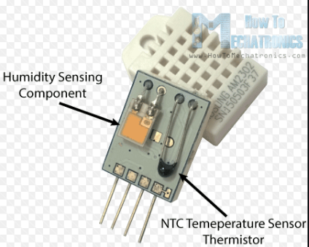

1. Capacitor: this element is used to measure the humidity of the environment. They consist of two electrodes and a moisture-holding substrate. The value of capacitance is affected where there is a change in levels of humidity. When there is a change in resistance value, it is measured and processed by the IC and is converted into digital form and is sent to the microcontroller.

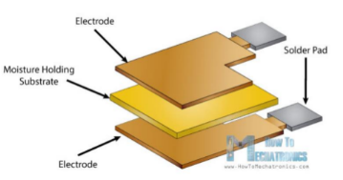

1. Negative Temperature Coefficient: this element is used to measure the temperature of the environment. The main advantage of this element is that semi conductive material is used which is flexible to change the resistance value with minor temperature change. The formula that thermistor follows where the measured value of the temperature is equivalent to the reciprocal of the resistance value.

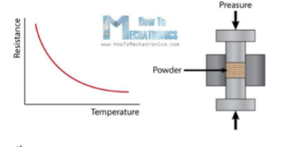

**THE FEATURES OF THE DHT11 SENSOR**

* Relative temperature and humidity measurements
* Calibrated digital output signal long term stability
* Low power consumption
* Provides transmission range for longer distance

**THE COMMUNICATION PROCESS OF THE DHT11 SENSORS**

1. Request: the readings of the sensor are sent as a request which is made. The request is to pull down the bus for more than 18ms. This makes the DHT understand that it’s a request and pull it up to 40 microseconds.

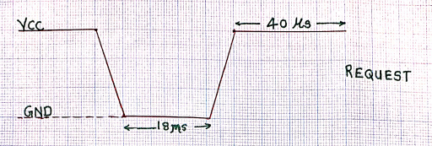

1. Response: it is an automatic reply from the DHT once it receives the request. The response is 5 microseconds low and 80 microseconds high.

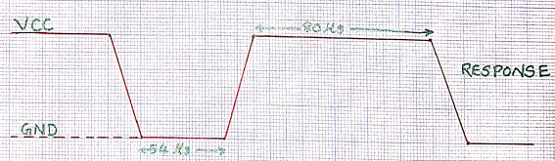

1. Data Readings: the sensor data follows the response. The data packet of 5 segments of 8 bit each is sent so we have 40 bit in total.



The first four segments read humidity and temperature then integral and decimal. The last segment is the checksum which is supposed to be equal to the sum of the first four segments. If they are not equal then it means that correct data has not been received.

**SPECIFICATION OF THE DHT11 SENSOR**



IMPLEMENTATION

It is important to study the usage of GPIO pins on the Raspberry pi, before interfacing with the sensors. The building of hardware based project with Raspberry pi becomes challenging because it is tricky to use the GPIO pins.

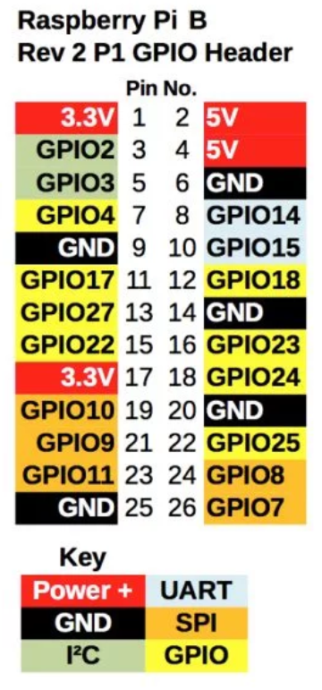

A Python program has made the access to the Raspberry Pi GPIO pins easier. Since python is a powerful language, it has clean syntax, gives more priority on readability of the program and uses meaningful English keywords.

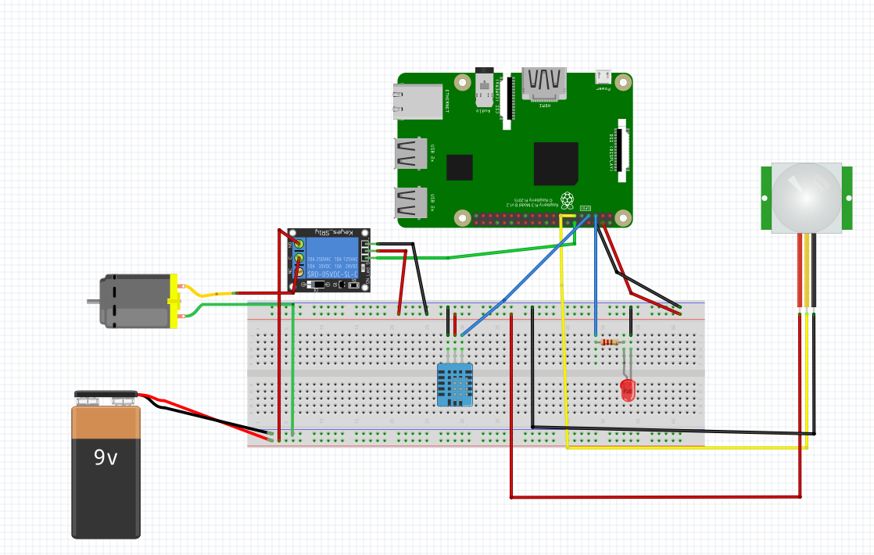

In this circuit, We have used the PIR sensor and DHT11 sensor. Smart home automation can be built by using these sensors to control the appliances. The black wire represents the Ground and the red wire represents the power supply. The 5V and Ground of the GPIO pins are connected to the positive and negative terminal of the breadboard so that the power supply is shared among the components. The PIR sensor is connected to the Raspberry pi along with the LED.

the PIR sensor has 3 pins which are VCC, Ground, and Signal. The yellow wire of the PIR sensor is connected to the GPIO17 pin. The red and blue wire of the PIR sensor is connected to the positive and negative terminal of the breadboard.

The cathode of the LED is connected to the ground and anode of LED along with a 330-ohm resistor is connected to the GPIO3 pin. Raspberry Pi GPIO pins supply 3.3 V at 50 mA and the LED supply 2V at 4 mA. A resistor has to be connected between the LED and GPIO pin since it depletes the Voltage from the GPIO pin of the Raspberry pi. According to the Ohms law, (V=IR) so a resistor with a value of 330 ohms is required.

After the connection of the PIR sensor and LED is done. A python library is installed by typing sudo apt-get install python-gpiozero. Since this library would allow accessing the GPIO pins.

A Python file can be created from the terminal by typing ‘nano autolight.py’. the code of the file is given below. After running the file, the PIR sensor detects the motion and control the LED. if any object is placed in front of the PIR sensor, the LED would be turned on by displaying the message ‘intruder detected, LED is on’ and if there is no object, then LED would be turned off with a message ‘No intruder, LED is off’. The process of detection and control of the LED is updated after every 0.1 sec as given in the code below.

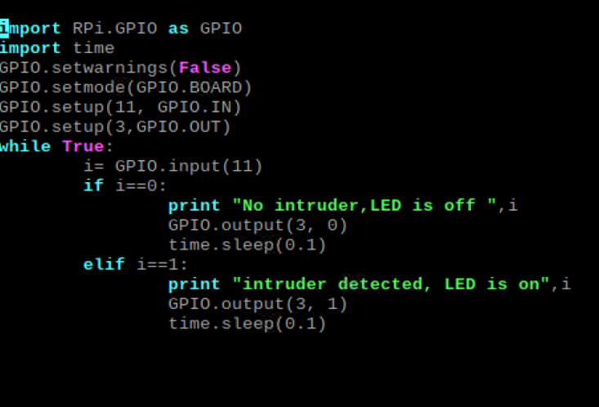

The result of the light control file is

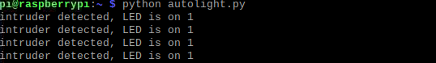

The DHT11 sensor has 3 pins which are VCC, Ground, and Signal. The read wire of DHT11 is connected to 5V of the Raspberry Pi and black wire connected to the Ground. The blue wire of the DHT11 sensor is connected to the GPIO4. After the connection is done, A library is installed named ‘Adafruit DHT ‘which can provide the access to readings of the DHT11 sensor. The installation can be done by typing ‘sudo pip install Adafruit_DHT’. or pip3 for the latest version of Python ‘python3’. (Raspberry Pi: Measure Humidity and Temperature with DHT11/DHT22, 2020)

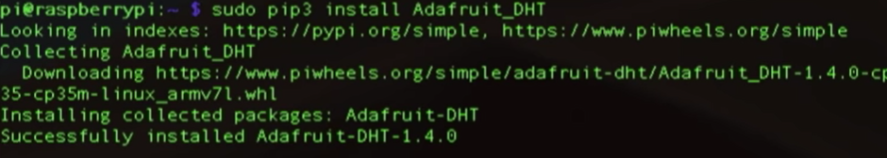

After the installation is done, we can check the sensor readings by typing ‘sudo python home/pi/Adafruit_Python_DHT/examples/AdafruitDHT.py 11 4’



The DC fan with yellow wire is connected to C pin and 9V battery with red wire is connected to NO pin of the relay module. The battery is used since the DC fan works on a 9V power supply. the DC fan with green wire is attached to the black wire of the 9V battery. Following this, the relay is connected to the Raspberry pi GPIO18 pin. Two Python files are created to turn the DC fan on and off.

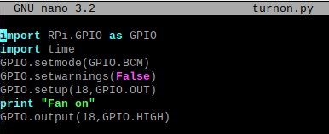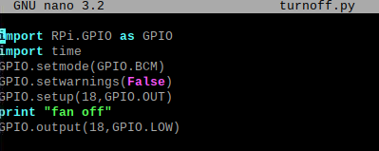

After the python file for relay is created, A bash script is created with ‘nano tempcontrol.sh’ where it can access and run the required python file . The codes are given below. This program displays the current time along with the date. It captures the data of temperature and humidity from AdafruitDHT library and displays on the screen. The value of temperature and humidity is compared and gives an output by running the python file for the DC relay to on and off. If the temperature or humidity is high, the DC fan would be on else if the levels are normal, the DC fan would be switched off. The data is updated every 3 seconds. To make the file executable, the compilation of file is done by ‘chmod +x tempcontrol.sh’

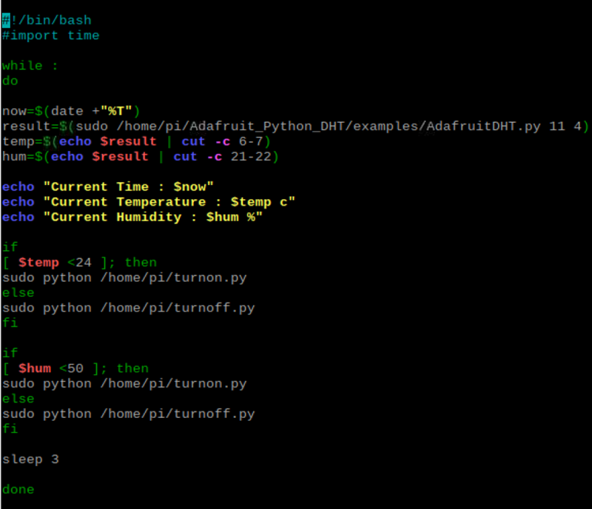

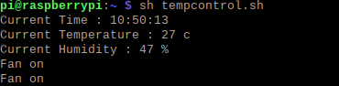

A menu is created in bash script ‘nano smarthome.sh’. This script displays a list of options that can run any program file with a specified location, then the compilation is done by entering ’chmod +x smarhome.sh’.The menu is created with case statements. If the user wants to control any appliances, the program will run based on the value entered.

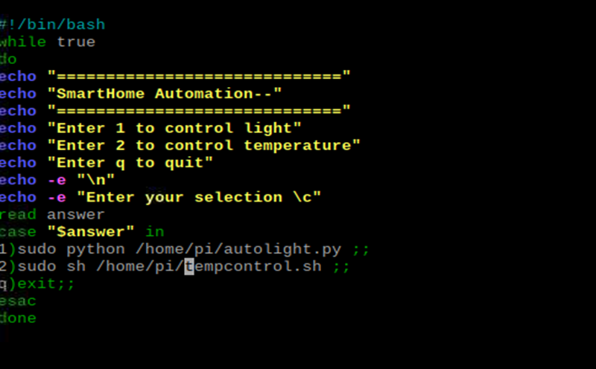

The result of the smarthome.sh

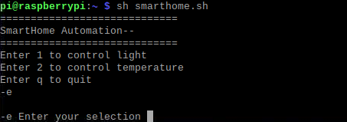

If 1 is entered, it would run the autolight.py file.

If 2 is entered, it would run the tempcontrol.sh file

If q is entered, it would exit the menu

CONCLUSION

In the field of the internet of things, using Raspberry pi as a microcomputer can facilitate innovative projects.

A home automation system is gaining popularity and holding its place as a mandatory feature of every home. Eventually, Every home will be automated. To achieve this path the implementation of this system and making it an affordable idea, so that it is available for every home. This will be possible if the components used in the design are reasonable, efficient, and reliable. The proposed design uses a Raspberry pi, PIR sensor, and DHT sensor, which are living up to the expectation. The simple and affordable design can further be enhanced and customized as per requirement. A generic model can be manufactured in mass which could be further customized and tailored as per requirement for installation. We still can buy the idea of enhancement, i.e, controlling, and monitoring through mobile with some add on such as Bluetooth module or WiFi module in the hardware and application design as a software.

This system has achieved in controlling light with PIR sensors and fan with the DHT11 sensor. The system indicates the user about the environment of the home. This system is programmed using python and bash script. A python file is created to control the lights for example, if anyone enters the room, the motion sensor would detect the object and turn on the light for him/her. This system also has a feature of monitoring the temperature of the room and switching the fan on or off based on the temperature detected by the DHT11 sensor. A python file is created to activate and deactivate the relay which is connected by fan and 9V battery. A bash script is created to control temperature by activating and deactivating the relay python file. Since this system uses small voltage appliances, it can also be used to control 220V AC appliances by connecting the relay module with a higher external power source where the appliances have to be powered up by plugging in.

Focusing on the advantages of this system that gives a scope as a must-have for every home is as follows.

* Managing the functionality with a convenience factor that it is automated.
* A new device or appliances could be added with a simple up-gradation as per the design.
* Controlling the device remotely can enhance the quality of life.
* Since the control of the appliances is programmed hence they are not redundantly used. This increases energy efficiency.
* The important factor is that the appliances will be used in an effective way and hence their functionality will be improved.

Ultimately to make home life easier, comfortable, and enjoyable. The homeowner must connect the appliances and other systems with automation technology.

REFERENCES

Pi, R., 2015. Raspberry pi 3 model b. *Online}. Tillgänglig: https://www. raspberrypi. org/products/raspberry-pi-2-model-b/{Använd 10 02 2016}*.

Monk, S., 2013. *Programming the Raspberry Pi: getting started with Python*. Mcgraw-hill.

Richardson, M. and Wallace, S., 2012. *Getting started with raspberry PI*. " O'Reilly Media, Inc.".

Goodwin, S., 2013. *Smart home automation with Linux and Raspberry Pi*. Apress.

Gay, W., 2018. DHT11 sensor. In *Advanced Raspberry Pi* (pp. 399-418). Apress, Berkeley, CA.

Vujović, V., and Maksimović, M., 2014, May. Raspberry Pi as a Wireless Sensor node: Performances and constraints. In *2014 37th International Convention on Information and Communication Technology, Electronics, and Microelectronics (MIPRO)* (pp. 1013-1018). IEEE.

Adafruit Learning System. 2020. *PIR Motion Sensor*. [online] Available at: <https://learn.adafruit.com/pir-passive-infrared-proximity-motion-sensor/how-pirs-work> [Accessed 25 April 2020].

Components101.com. 2020. *DHT11 Sensor Pinout, Features, Equivalents & Datasheet*. [online] Available at: <https://components101.com/dht11-temperature-sensor> [Accessed 25 April 2020].

Raspberry Pi Tutorials. 2020. *Raspberry Pi: Measure Humidity And Temperature With DHT11/DHT22*. [online] Available at: <https://tutorials-raspberrypi.com/raspberry-pi-measure-humidity-temperature-dht11-dht22/> [Accessed 25 April 2020].